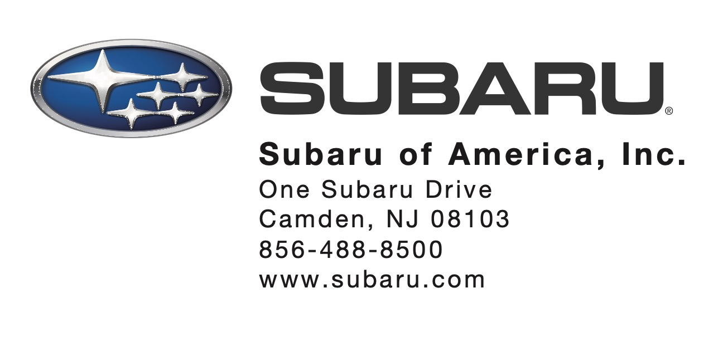

To: All Subaru Retailers
From: Subaru of America, Inc. – Service Department
Date: November 26, 2021
Subject: Midtronics Battery Test Equipment Software Updates

We are pleased to announce software updates to the Subaru Midtronics DSS-5000 Battery Diagnostic Service System and DCA-8000 Dynamic Diagnostic Charging System. The software versions will be updated to revision “N” for the DSS-5000 and “H” for the DCA-8000. The updates will be pushed to the tools within the next few days.

What’s New – DSS-5000 and DCA-8000:
- Updated Make/Model Table: The internal database has been updated with the latest 2022MY information available so once the VIN is entered, the vehicle is correctly recognized and ready for testing.

NOTES:
- For issues related to the DSS-5000 or DCA-8000, please contact Midtronics customer support at: 800-776-1995.
- For issues related to the SDS network or the Brother printer please contact Nuspire at: 877-782-7404.
- Please consult the DSS-5000 and DCA-8000 knowledge bases for more information using the links below:
  - https://subaru.dss5000.com/
  - https://subaru.dca8000.com/

Battery testing using Midtronics Battery Test and Charge equipment is required whenever performing battery replacement in all Subaru warranty cases except for leaking batteries.

Test results from the DCA-8000 Dynamic Diagnostic Charging System and DSS-5000 Battery Diagnostic Analyzer including the Battery Test Code required for claim submission are automatically uploaded to the BMIS website for easy retrieval. Claims for battery test results not uploaded to BMIS may be rejected or debited. Please ensure your machines are uploading test results to the BMIS server on a regular basis.
User Manuals for the Midtronics tools can be found on STIS.

If you have questions, please contact Subaru Service Operations at serviceoperations@subaru.com.

a subsidiary of Subaru Corporation

